**BDA LAB - Customers Database**

**Perform the following DB operations using MongoDB.**

1. Create a collection by name Customers with the following attributes.

Cust_id, Acc_Bal, Acc_Type and insert appropriate values.

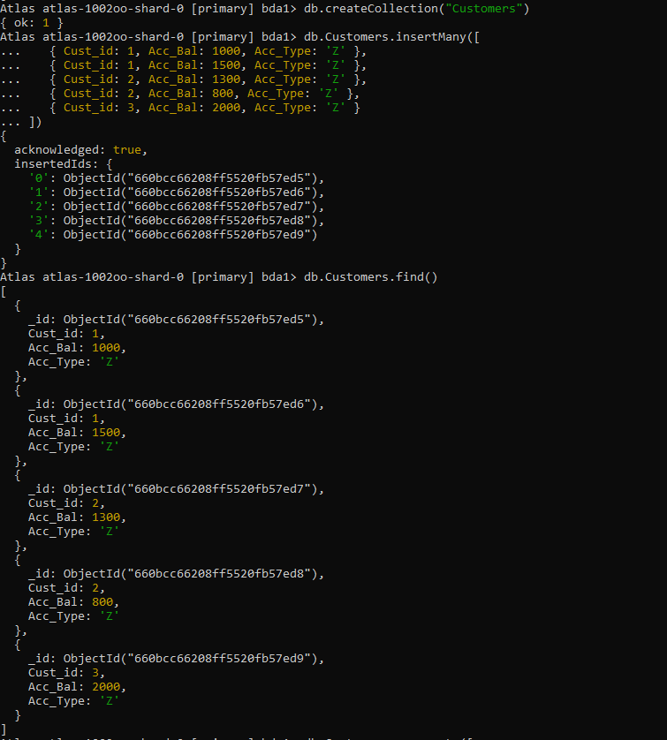

2. Write a query to display those records whose total account balance is greater than

1200 of account type ‘Z’ for each customer_id.

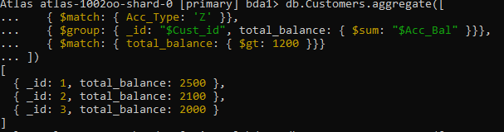

3. Determine Minimum and Maximum account balance for each customer.

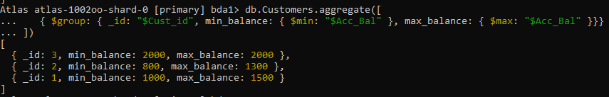

4. Sort the documents based on Customer ID in ascending order and Account Balance in descending order.

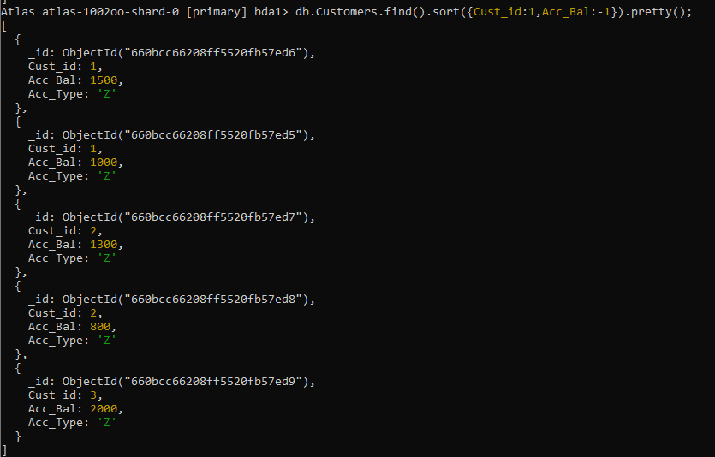

5. Display only 2nd and 3rd records from the collection

